Dezentrales Daten Speicher System

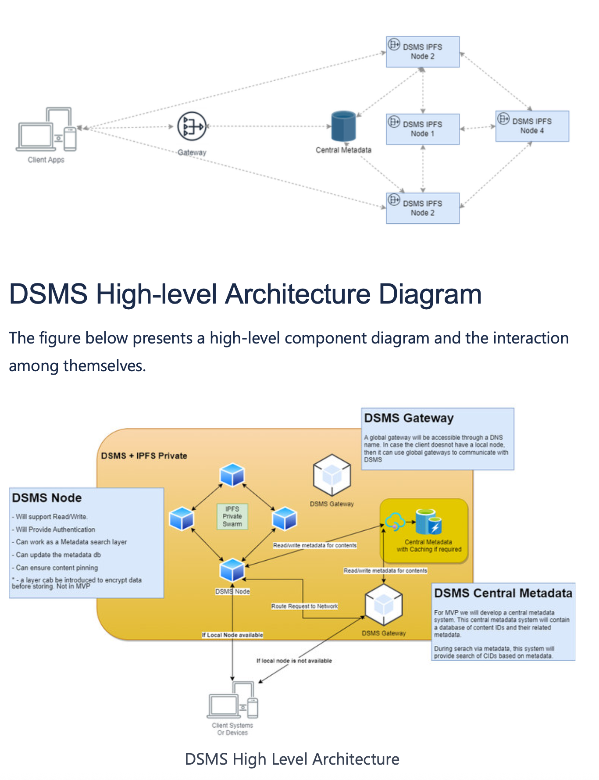

Table of content
Table of content
Purpose
Logical Architecture
DSMS High-level Architecture Diagram
Components
DSMS Node
DSMS Node Agent
Backend Service
Frontend Service
DSMS Gateways
Central Metadata system
How it works
How “Read request” works (with Caching)
How “Write request” works
Content Retention
How does Garbage Collection Work
How Authentication works
Web3auth.io :
CRUST Network :
How Metadata search works
High-level Task Breakdown
Next Steps
References
Purpose
This page will explain the high-level design of the DSMS system for the MVP.
The solution is based on a private IPFS network.Logical Architecture
This section explains the high-level logical architecture of the proposed
solution as shown in the image below.
The DSMS system will consist of several logical components like Gateways,
Nodes, a Central metadata system, and an admin interface. A quick overview of
the components is provided below.
DSMS High-level Architecture Diagram
The figure below presents a high-level component diagram and the interaction
among themselves.
DSMS High Level ArchitectureComponents
DSMS is a distributed network of nodes + gateways that is extendable and
customizable. The DSMS system will allow adding new nodes or gateways at
any time. In terms of hardware, a node can be a server, SOC or Linux-based
device with a DSMS Node Agent installed on it.
DSMS Node
DSMS node is a physical hardware device (computer, or carihub etc) that is
running the DSMS Node Agent on it. The figure below demonstrates a high-
level design/architecture of DSMS Node and DSMS Gateway. Moreover it
demonstrates the types of DSMS Agents i.e. Node Agent and Gateway Agent.
DSMS Node Agent
DSMS Node Agent is a customized software that will be installed on a
computer of device to make it a DSMS node i.e. this computer will become a
part of DSMS private network.
The DSMS Node Agent will have two components/Services i.e. backend service
and frontend service (as shown in Figure 1 below).DSMS Node + Gateway Architecture
Backend Service
This service handles all the networking and p2p communication between
nodes. A backend service is a background service (Linux daemon)
responsible for chunking contents, storing the contents in disk,
communicating with other nodes for content storage/retrieval and
managing Distributed Hash Table etc.
The backend service will inherit all these features from out of the box IPFS
node client software. There will be some minor customization like fixed
swarm key/network identification to make sure all nodes in a DSMS
network will be communicating privately.
A typical IPFS node uses libraries like libp2p to manage the communication
between nodes. Moreover, the rest of the services like chunking, making
Merkle Graph, storing chunks, and retrieving chunks using Bitswap protocol
is all available out of the box. DSMS system will leverage these features as-
is.
Frontend Service
This service acts as an HTTPS/REST interface of DSMS System for external
client software. A custom HTTP/REST-based interface will be developed on
top of IPFS (out of the box) gateway service. These additional layers will be
developed to allow additional features like metadata management,
metadata-based search, and authentication etc.
The figure 1 above shows that a DSMS node will have a custom local
gateway which will be a wrapper (green color components) on the existing
Backend services (red color services). A custom HTTP/REST-based interface
for the external systems will be developed to allow additional features likefor the external systems will be developed to allow additional features like
metadata management, metadata-based search, and authentication etc.
These APIs will perform various functions like forwarding contents storage
request to network, storing the mapping of metadata to CID in CMS,
managing authentication, and some other stuff required to run DSMS.
DSMS Gateways
Any computer or system with DSMS Gateway Agent software installed will
become a DSMS Gateway. The gateways will be globally accessible service. It
will be accessible through DNS names e.g. https://etostorage.io/{{}}. If a client
application is at a location where there is no local node available then it can call
the gateway to talk to DSMS Network.
The gateway will act as router to rout the requests from client to the nearest
DSMS Node. It will have same HTTPS/REST interface as that of a local gateway
service of a DSMS agent.
Central Metadata system
The system will have search capabilities based on central metadata maintained
for all the contents stored on the network. For the MVP, the search will depend
on this central information store. We can make it resilient by introducing
redundancy in the database.
The Gateways will receive the content POST request with metadata. It will
forward the metadata to CMS and the contents to the storage network. This
metadata will later be used for searching based on metadata.
e.g. For city guide if a user requests files for a specific range of
latitude/longitude then it can look into the metadata to search associated files.
How it works
The DSMS system will be available to client applications and devices in two
different scenarios i.e.
The client has a local node
The client does not have a local node available.The client does not have a local node available.
With Local Node
In a scenario where the client is maintaining a local DSMS node, the client
device/software will be connected to local node. All the requests will land to the
local node which will forward those requests to the network services running in
the background.
Without Local Node
If the client is far away from the local node or not connected to the same
network, the request is routed to the Gateway which is available for client that
do not maintain a local node.
Any request to read/write or search contents will be forwarded to a nearby
node. This node will be able to access the entire network for any request.
How “Read request” works (with Caching)
(Use Case 3: https://eto-dev.atlassian.net/wiki/spaces/DSMSD/pages/74940476
/Business+Case+for+the+City+Conference#Use-Case-3 )
1. When a Get content (Get by CID) request reaches the node through the
global or local gateway, the IPFS then uses the DHT to locate the content in
the nodes storing blocks associated with a content-addressed hash and
retrieve them to reassemble the original file.
2. The content is first looked up in local storage of the node and is returned if
it is available.
3. If the content is not available locally then the current node shares a
“wantlist” to all peer nodes to lookup for the available chunks of the
requested content.
4. The peer nodes return the confirmation back to initiator node and then this
node request for actual chunks. All the returned chunks are assembled, and
file is compiled back.
5. All the above steps from step 3 onwards are achieved by using the Bitswap
protocol already available in IPFS codebase.
6. Please note that this process ensures that the contents are cached on the
node where the actual request was received. This is called local caching of
contents. It is called “Local” because the request from client is usually
landing in the nearest node of the client. Therefore, if the contents were notnearest nodes for the first time, the process makes sure that
landing in the nearest node of the client. Therefore, if the contents were not
available on contents will be cached on this nearest node for next requests. We can also
refer to this as geolocation-based caching. This improved the performance
of consequent request for the same contents.
7. The content is then delivered back to the client as a response to the HTTPS
request made by the client.
8. The content caching has a configurable expiry too.
9. The client can access the content directly from the gateway or download it
to their device for offline use.
How “Write request” works
(Use Case 1 https://eto-dev.atlassian.net/wiki/spaces/DSMSD/pages/74940476
/Business+Case+for+the+City+Conference#Use-Case-1 )
1. The client (application or device) selects the file to upload. Moreover, there
would be some metadata that is required to be uploaded along with actual
file contents.
2. The client application makes an HTTPS request to a DSMS gateway using
REST API to post a file. The metadata can be posted at the API request body
(json format). The metadata would be flexible and will not have a fixed data
structure or pattern.
3. DSMS will treat all the metadata as a key value pair (hierarchical -TBD).
4. The DSMS backend services will read the request and perform two-step
process.
a. Forward the file storage request to IPFS node. This request will return a
CID. The internal process of chunking and storing the file is briefly
explained below, but sine this is all handled by IPFS automatically, so the
details are not recorded here.
i. IPFS will create chunks of the file
ii. Each chunk is given a unique identifier called a content-addressed
hash.
iii. Then it creates a data structure called a Merkle DAG that represents
the file, including the content-addressed hashes of its chunks.
iv. The Merkle DAG is stored on the IPFS network, and the chunks are
distributed across multiple nodes.
v. The file is broken down into smaller pieces called chunks.v. The file is broken down into smaller pieces called chunks.
Each chunk is given a unique identifier called a content-addressed
hash.
The user's IPFS client creates a data structure called a Merkle DAG
that represents the file, including the content-addressed hashes of its
chunks.
The Merkle DAG is stored on the IPFS network, and the chunks are
distributed across multiple nodes.
The content identifier (CID) is generated for each chunk.
The user can access the file on the IPFS network by using the
content-addressed hash of the Merkle DAG.
vi. The content-addressed hash of the Merkle DAG is returned as CID
from file storage request to IPFS.
b. CID for the file and associated metadata from the actual request will be
stored in CMS using CMS API to write metadata.
5. To ensure that the content remains available on the network, DSMS will use
the PIN command by default. This will ensure that the content is persisted
on local node permanently.
6. The other option is to use the IPFS cluster to replicate and distribute the
content across multiple nodes. This is post MVP research item.
7. Pinning also ensures that the content is not removed from the network due
to garbage collection or other factors.
Content Retention
When a user uploads content to the IPFS network, it is securely stored on a
node and propagated throughout the network for a limited period. IPFS
employs content-addressed links, which generate a unique hash for each file to
ensure the integrity of its content. Therefore, any file added to the IPFS network
can be accessed and retrieved by anyone with the hash, even if the original
uploader is no longer available. However, if the content is not accessed within
the specified time limit, it is deemed unnecessary and automatically removed
from the network by Garbage Collector.
How does Garbage Collection WorkHow does Garbage Collection Work
1. Garbage collection is a mechanism that removes data from the local storage
of a node that is no longer being used or referenced by other nodes in the
network
2. IPFS uses a content-addressed data model, where data is identified by its
content identifier (CID) and stored in a Merkle DAG (Directed Acyclic Graph)
structure. This means that objects in IPFS can have multiple parents and are
immutable.
3. During garbage collection, to determine which objects are still needed and
which can be safely deleted IPFS uses a reference counting mechanism to
keep track of the number of links to each object in the Merkle DAG.
4. The node will traverse the Merkle DAG starting from the root and mark each
object it encounters as either needed or not needed.
5. When an object is no longer needed, its reference count will be zero, and it
can be safely deleted.
6. To optimize garbage collection, IPFS uses several techniques such as bloom
filters and partial DAG traversal to avoid unnecessary processing and
minimize the risk of accidentally deleting needed objects.
7. Garbage collection can be a resource-intensive process, so it's important to
carefully consider the frequency and timing of garbage collection to avoid
negatively impacting the node's performance or availability.
How Authentication works
(Research still in progress)
Here are few options for authentication & authorization in IPFS:
Web3auth.io http://Web3auth.io :
It provides a user-friendly and secure way for users to authenticate with
decentralized applications (dApps) using their Web3 identities. It is based on
the OAuth 2.0 protocol. Here are the steps involved in the authentication
process:
1. User signs in to the DApp: When a user wants to access a decentralized
application (DApp) they can sign in using their Ethereum wallet. The DApp
sends a request to http://Web3auth.io , indicating that the user wants to
sign in.sign in.
2. Once the request is received, Web3auth.io requests a signature from the
user's wallet. This signature is used to verify the user's identity.
3. The user is prompted by their wallet to approve the signature request. Once
approved, the wallet generates a signature that is sent back to Web3auth.io
.
4. Web3auth.io verifies the signature using the Web3auth smart contract on
the Ethereum blockchain. If the signature is valid, the user is authenticated.
5. Once the user is authenticated, the DApp checks the user's permissions
using the Web3auth smart contract. The smart contract stores information
about the user's roles and permissions, which are used to determine what
actions the user is authorized to perform.
6. If the user's permissions allow them to perform the requested action, the
DApp allows the user to perform the action. If the user's permissions do not
allow them to perform the requested action, the DApp denies the action
and provides an appropriate error message.
7. If the user's permissions are updated (e.g. if their role is changed), the
Web3auth smart contract is updated to reflect the new permissions. This
ensures that the user's permissions are always up to date.
CRUST Network https://wiki.crust.network/docs/en
/buildIPFSWeb3AuthGW:
It uses a lightweight Web3-based authentication service based on IPFS gateway
and reverse proxy as shown in Figure 3 below.
Figure 3
Here are the steps involved for the authentication process:1. When a user wants to upload any content to IPFS they need to fetch Public
and Private key from their web3 wallet
2. Sign the Pubkey(0x123) with their private key and get the Sig(0x456)
3. Call original IPFS API(/api/v0/add) with basic auth header(Basic
0x123:0x456)
After Web3 Authenticator recieves the request:
1. It will parse the header, extract Pubkey(0x123) and Sig(0x456)
2. Parse Sig with Pubkey, then get the Msg(0x123), determine whether the
Msg and Pubkey are the same
3. If Msg and Pubkey are not the same then authentication has failed
How Metadata search works
(Use Case 2: https://eto-dev.atlassian.net/wiki/spaces/DSMSD/pages/74940476
/Business+Case+for+the+City+Conference#Use-Case-2 )
1. Central metadata stores the mapping of metadata fields and CIDs.
2. Whenever search is performed based on field/fields in metadata it filters the
data based on specified parameters and returns associated CIDs.
3. Files can later be retrieved using the filtered CIDs from storage.
Note:
As a post MVP task we can also look into Elastic Search or Apache Solr to
optimize searching based on - metadata.
We can also look into developing decentralized metadata for this system.
High-level Task Breakdown
This is elaborated in the following document https://eto-dev.atlassian.net
/wiki/spaces/DSMSD/pages/96895025
/Cost+estimate+for+MVP#Development-Cost%3A
Next Steps
1- Update document with all API Interfaces1- Update document with all API Interfaces
2- Document workflows (acutal use cases working with our design)
3- Explore new technologies like gRPC, GraphQL etc
References
1- A Technical Guide to IPFS – the Decentralized Storage of Web3
(freecodecamp.org)
2- ipfs-http-client - npm (npmjs.com)
3- Auth plugin Release the BATs (block level access control in IPFS)
(peergos.org)
IPFS W3Auth Gateway · Crust Wiki
4- Bitswap Bitswap | IPFS Docs
5- IPFS Node technical guide - https://www.freecodecamp.org/news/technical-
guide-to-ipfs-decentralized-storage-of-web3/

